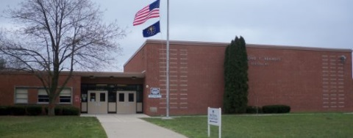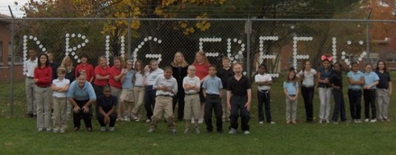

Principal

Lauren Johnson

Administrative Associate

De’Vonna Carlisle

Parent Involvement Educator

Angela Knight

Social Worker

Brenda Fuller

School Hours (2016-2017)

9:15 a.m. - 3:50 p.m.

School Hours (2017-2018)

8:15 a.m. - 2:50 p.m.

Office Hours

8:00 a.m. - 4:30 p.m.

Open House

Thursdays 9:30-11:30 and

12:30-3:30

Or call for an appointment

4065 Asbury Street

Indianapolis, IN 46227

Phone: 317.226.4265

Fax: 317.226.3392

<http://65.ips.k12.in.us/>

IPS Raymond F. Brandes School 65

@IPSBrandes65

**Family Engagement**

Raymond Brandes Elementary School provides many opportunities for families to be involved. Our Parent Pit Crew allows time for families to help plan activities, share suggestions and experiences, and provide encouragement for each other.

At least twice a month families participate in activities that help build literacy and math skills and foster the school’s sense of community. During the day parents and guardians are encouraged to eat breakfast or lunch with their children, read with children, visit classrooms, and volunteer in the school.

# RACING TO THE WINNER’S CIRCLE

# OF LEARNING!

**Raymond F. Brandes Elementary School**

**Clubs & Activities**

* College Mentors
* Technology, Science, Art, Choir, Yearbook, and Physical Fitness Clubs including Girls on the Run
* Basketball, Soccer, and Volleyball Teams
* After School Tutoring
* Intersession and Summer School

**Community Partnerships**

* University of Indianapolis
* Center for Excellence in Leadership of Learning
* University Heights Neighborhood Association
* University Heights Methodist Church
* Apostolic Christian Church
* Laurelwood Community Center
* Walmart Neighborhood Market
* Noble Romans
* McDonalds
* Kennan-Stahl Boys and Girls Club

# School Highlights

* Community school with caring staff and partners
* Pre-kindergarten program
* Highly engaging fiction and non-fiction embedded in instruction
* Daily remediation and enrichment in literacy and math
* Promethean Boards, IPads, and computers in every classroom
* Technology integrated into all subjects
* Daily academic strategy during morning announcements
* Monthly career focus
* Community service activities
* Presentations facilitated by University of Indianapolis students and staff
* Mentors from University of Indianapolis faculty, staff, and students
* Instrumental music and choir

# Mission Statement

The administration and staff of Raymond F. Brandes Elementary School IPS #65 believe that all children deserve a rigorous education that enables them to reach their highest potential. At Raymond Brandes Elementary School this is done through high quality learning experiences that provide students with opportunities to: interact and work with others in the school and community, use technology for learning and communication, explore different career fields, and develop a sense of global responsibility and community citizenship by participating in community service projects and events.