Behavior, Motivation, and the Battle of the Brain(s) An AP Not IEP Staple

Dr. Linda Karges-Bone

As we build an “AP Not IEP” culture, classroom management often emerges as a critical point of discussion. Let’s begin the work here, with a look at brain-based classroom management.

The *History Channel* aired a fascinating two hour feature on “The Brain” and not surprisingly, the opening lines compel those who work in classrooms to pay attention. “Scientists are only now beginning to understand the most complex machine in the known universe--the brain. Go on a voyage of discovery into the evolutionary history of our last biological frontier. From early civilizations' attempts at neuro-surgery to today's robotic laser surgery, revolutionary new techniques are finally unlocking the story of the brain. As a result, we've learned more in the last five years than in the past 100.” ( The History Channel, 2009)

Interestingly, almost 1/3 of the program dealt with the unique role of the *amygdalas*, which appear frequently in our discussions of clients motivation, management and brain science. (Karges-Bone, 2010) These almond-shaped structures, one on each side of the pre-frontal cortex, activate to warn us of danger, and in doing so, make thinking and planning difficult. It is like a “battle of the brains”, with the amygdalas and the cortex fighting for supremacy.

To that end, the Navy Seal program, according to the television special, reached out to neuro-biologists and educators to find out how to teach their candidates, who were failing out of the program at an alarming rate, how to master the amygdalas, and make better, more focused decisions while under impossible stress. Does it sound like something activity directors could apply in their work with demanding, diverse groups?

Here’s the four step process that the experts are teaching the Naval Special Forces, and which has already improved their “pass rate” by 1/3.

1. **Set clear goals before the stress ensues.**
2. **Rehearse possible scenarios thoroughly so that they are “hard-wired” in the cortex.**
3. **Use positive “self talk” during the stressful experiences.**
4. **Practice deep breathing techniques to lower heart rate and blood pressure while under stress.**

Isn’t it interesting that Dr. Fred Jones, acknowledged “guru” of behavior management suggests some of these same strategies in his Tool box videos 6 and 7?[1] One of his caveats is to engage the “six second rule” before responding with nagging? As Dr. Jones reminds us: “Calm is Strength.” But, that is easier said than done in today’s chaotic social climate.

To help readers organize your plans or build a “schema” as we are fond of saying in cognitive science, I have developed a mnemonic device to apply in designing one’s own client management plan. Activity directors may apply my model in plans, citing this article. I call it the **TRIP strategy**. Think about taking a “TRIP” through your work- day without “Tripping” over errors and nagging in management. Here it goes:

# T……Target the goals that you want to achieve in your program. Target specific behaviors and teach them as procedures until your clients/participants master them.

**R…...Rehearse the right responses for yourself and with your group members.**

**I……Inhale deeply and invite your body and mind to work in tandem.**

P….Practice positive self-talk to yourself and powerful praise strategies[2] with your audience.

As educators develop their own management and motivational plans, it is helpful to respond to questions using the graphic organizer that follows. Keep in mind some of the following:

* Fewer, more focused goals are better.
* Coordinate your targets with existing best practices at your site.
* Remember to shape behaviors over time and to consider students’ diversity and prior experiences
* Rehearse lots of possible scenarios. Talk with trusted mentors about how they have managed behaviors successfully.
* Consider strategies from both extrinsic and intrinsic practices.
* Get enough sleep and exercise, so that you can access strength and stamina under stressful situations
* Apply “growth praise” that feeds the brain, using Dr. Carol Dweck’s models.

If it works for Navy Seals as they endure the toughest test, in which they must stay underwater for 20 minutes while master teachers tangle and tamper with their breathing lines and their bodies fight the primal response to surface, which would result in removal from this elite program, then it can work in your clinical experience. It is a mind-body connection in which the amygdalas and cortex battle for supremacy. Take the TRIP and see if you can win!

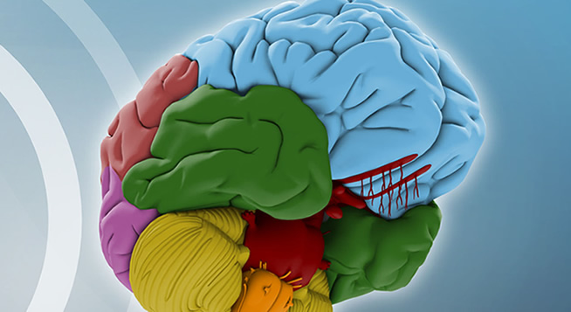

## TRIP Organizer

# T……Target the goals that you want to achieve in your program. Target specific behaviors and teach them as procedures until your clients/participants master them.



List 4-3 Targets or Goals for Program Management. Use these stems:

The participants will______________________

The AD will_______________________

**Identify specific procedures that you will employ to teach participants how to respond:**

**R…...Rehearse the right responses for yourself and with your participants.**



Brain-storm a few common situations in management that seem to keep coming up. What has your automatic response looked and sounded like? How can you make changes? Draw out one of them in the box:

**I……Inhale deeply and invite your body and mind to work in tandem.**



**Write down a few strategies that you can personalize that help you to slow down and breathe before you respond. Are there colors, scents, images that help?**

P….Practice positive self-talk to yourself and powerful praise strategies[3] with your audience members.



*What does “positive self talk” mean to you? Prayer? Reminders? A little voice in your head? What do you know to be true about the brain and praise? Why do Reminders? A little voice in your head? What do you know to be true about the brain and praise? Why do you and the clients/participants need this?*

In order to build your capacity for calm, find a wonderful piece of scripture or poetry and write it here, to serve as you mantra for management.

1. Jones, F. ( 2008 ) The Classroom Management Video Toolbox. http://www.fredjones.com/
2. Dweck, C. ( 2008) *The Perils and Promises of Praise. Educational Leadership. ASCD.* Summer 2008. (65) pp.34-39.
3.